**DAY 2 PLANNING THE TECHNICAL FOUNDATION**

**Day 2 -- PLANNING THE TECHNICAL FOUNDATION**

**What was the problems of marketplace? What is the solution for marketplace?**

1. **Flexibility:** Rent furniture for temporary use instead of buying.
2. **Lower Costs:** Rent furniture for a fraction of the purchase price.
3. **Access to Quality:** Rent high-quality furniture without long-term commitment.
4. **Easy Delivery & Pickup:** Flexible delivery and return options.
5. **Trusted Rentals:** Centralized, reliable platform for renting or buying.
6. **Simplified Returns:** Clear return policies and easy furniture pickup.
7. **Short-Term Housing Needs:** Furnish temporary spaces without a large upfront cost.
8. **More Rental Variety:** Offer a wide range of rental furniture options.
9. **Sustainability:** Provide eco-friendly rental furniture options.
10. **Trust in Quality:** Detailed product info and reviews to ensure quality.
11. **Simplified Shopping:** Clear options for both renting and buying, reducing market confusion.
12. **No Flexibility:** Customers need temporary furniture but can only buy.
13. **High Costs:** Furniture is expensive for short-term use.
14. **Limited Quality Rentals:** Rental furniture options may not be good quality.
15. **Complicated Delivery & Returns:** Renting furniture can be hard to manage logistically.
16. **Untrustworthy Rentals:** Not enough reliable rental services.
17. **Complex Returns:** Rental return processes can be difficult.
18. **Short-Term Housing Solutions:** People moving temporarily struggle to find affordable furniture.
19. **Limited Rental Variety:** Few platforms offer diverse rental furniture options.
20. **Lack of Eco-Friendly Choices:** Limited availability of sustainable furniture.
21. **Trust Issues:** Customers worry about the quality and durability of rental furniture.
22. **Market Confusion:** Customers get confused with platforms offering only rentals or purchases.

### Target Audience: Unique Value Proposition:

1. Flexible Options
2. Affordable Pricing
3. Sustainability
4. Convenience
5. Wide Selection
6. Trust and Quality
7. Young Professionals 2. Students
8. Travelers/Expats 4. Small Families
9. Eco-Conscious Consumers
10. Budget-Conscious Shoppers
11. Interior Designers/Real Estate Agents
12. Homeowners for Seasonal Updates
13. Online Shoppers

**Key Features:**

1. **Rent or Buy Options:** Allow customers to choose between renting or purchasing furniture.
2. **3D Product Visualization/AR:** Let customers visualize furniture in their space with AR or 3D models.
3. **Flexible Delivery & Pickup:** Offer flexible delivery and return options for both rental and purchased items.
4. **Product Customization:** Allow customization of size, color, and material for both rented and purchased furniture.
5. **Easy Checkout Process:** Simple and secure checkout with payment options for both rental and purchase.
6. **Subscription & Rental Plans:** Provide different rental duration plans (daily, monthly, etc.).
7. **Eco-Friendly Section:** Highlight sustainable, eco-friendly furniture options.
8. **Customer Reviews & Ratings:** Allow customers to review products and share their experiences.
9. **Clear Return Policies:** Transparent return and exchange policies for both rentals and purchases.
10. **Search & Filter Options:** Advanced search and filters to help customers easily find the right furniture based on their needs (style, price, type, etc.).
11. **Live Chat Support:** Instant support for customers through live chat to answer questions and assist with decisions.
12. **Rental Agreement:** Easy-to-understand rental agreements for customers to review before renting.
13. **Wishlist & Favorites:** Let customers save their favorite items for future reference or purchase.

**Transitioning to Technical Planning**

**Technical Requirements**

* Frontend Requirements
* Sanity CMS as Backend
* Third-Party APIs

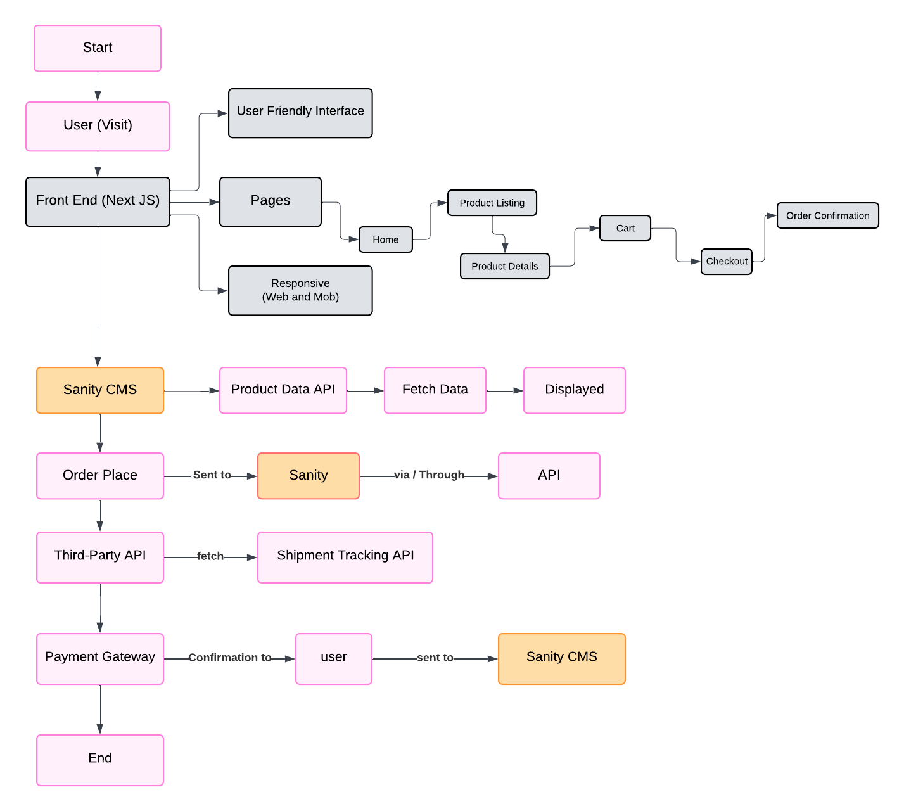

**User Registration/Login:**

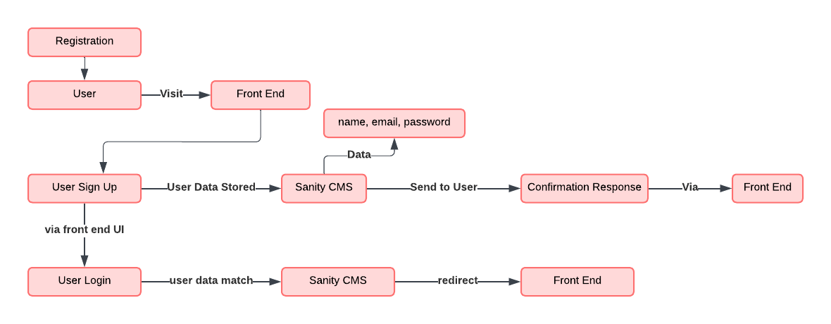

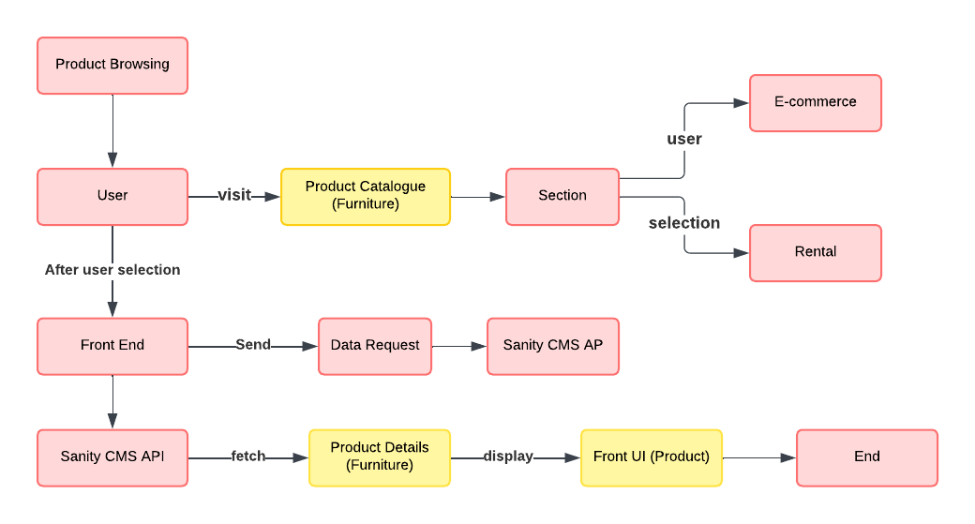**Product Browsing:**

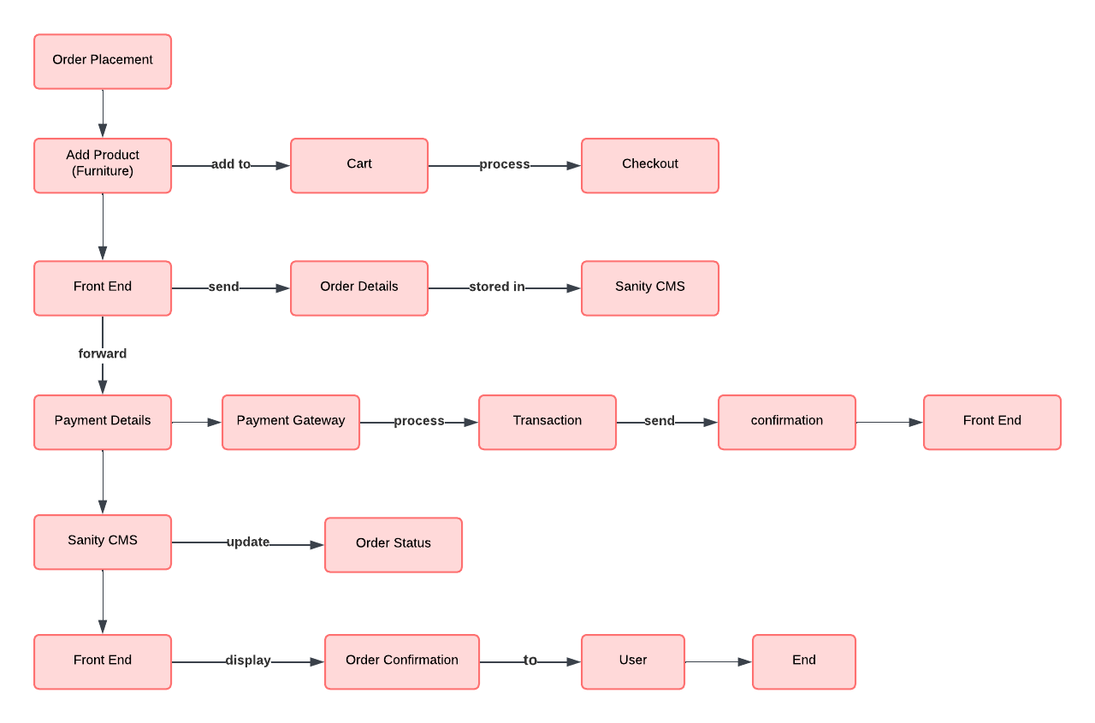**E-Commerce** **Order Placement Workflow:**

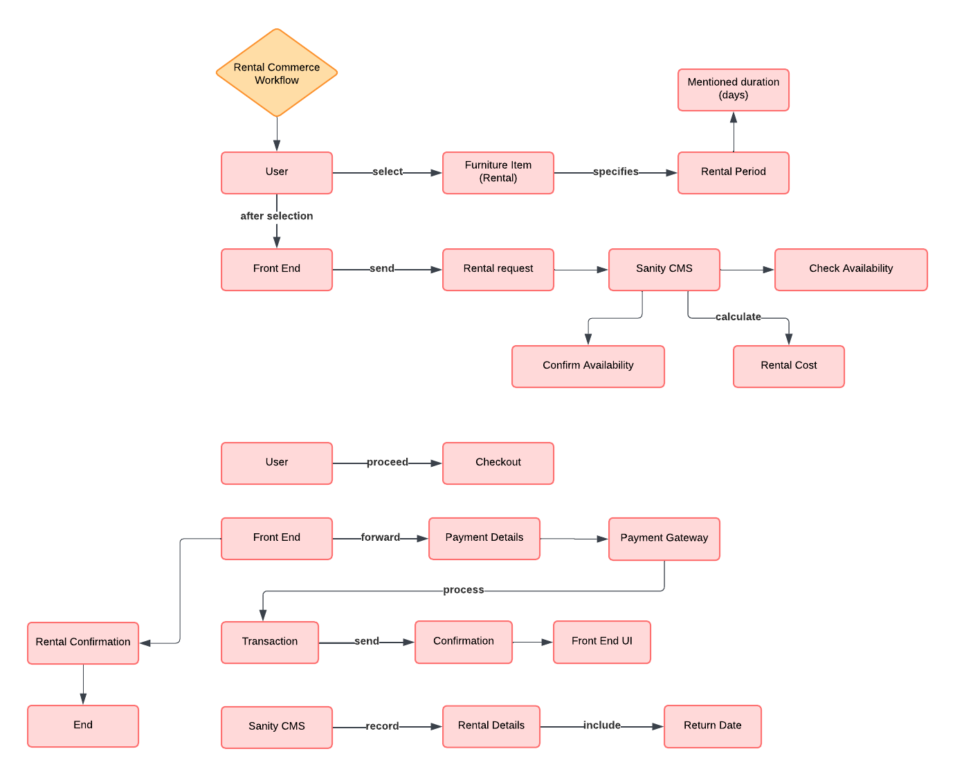**Rental Commerce Workflow:**

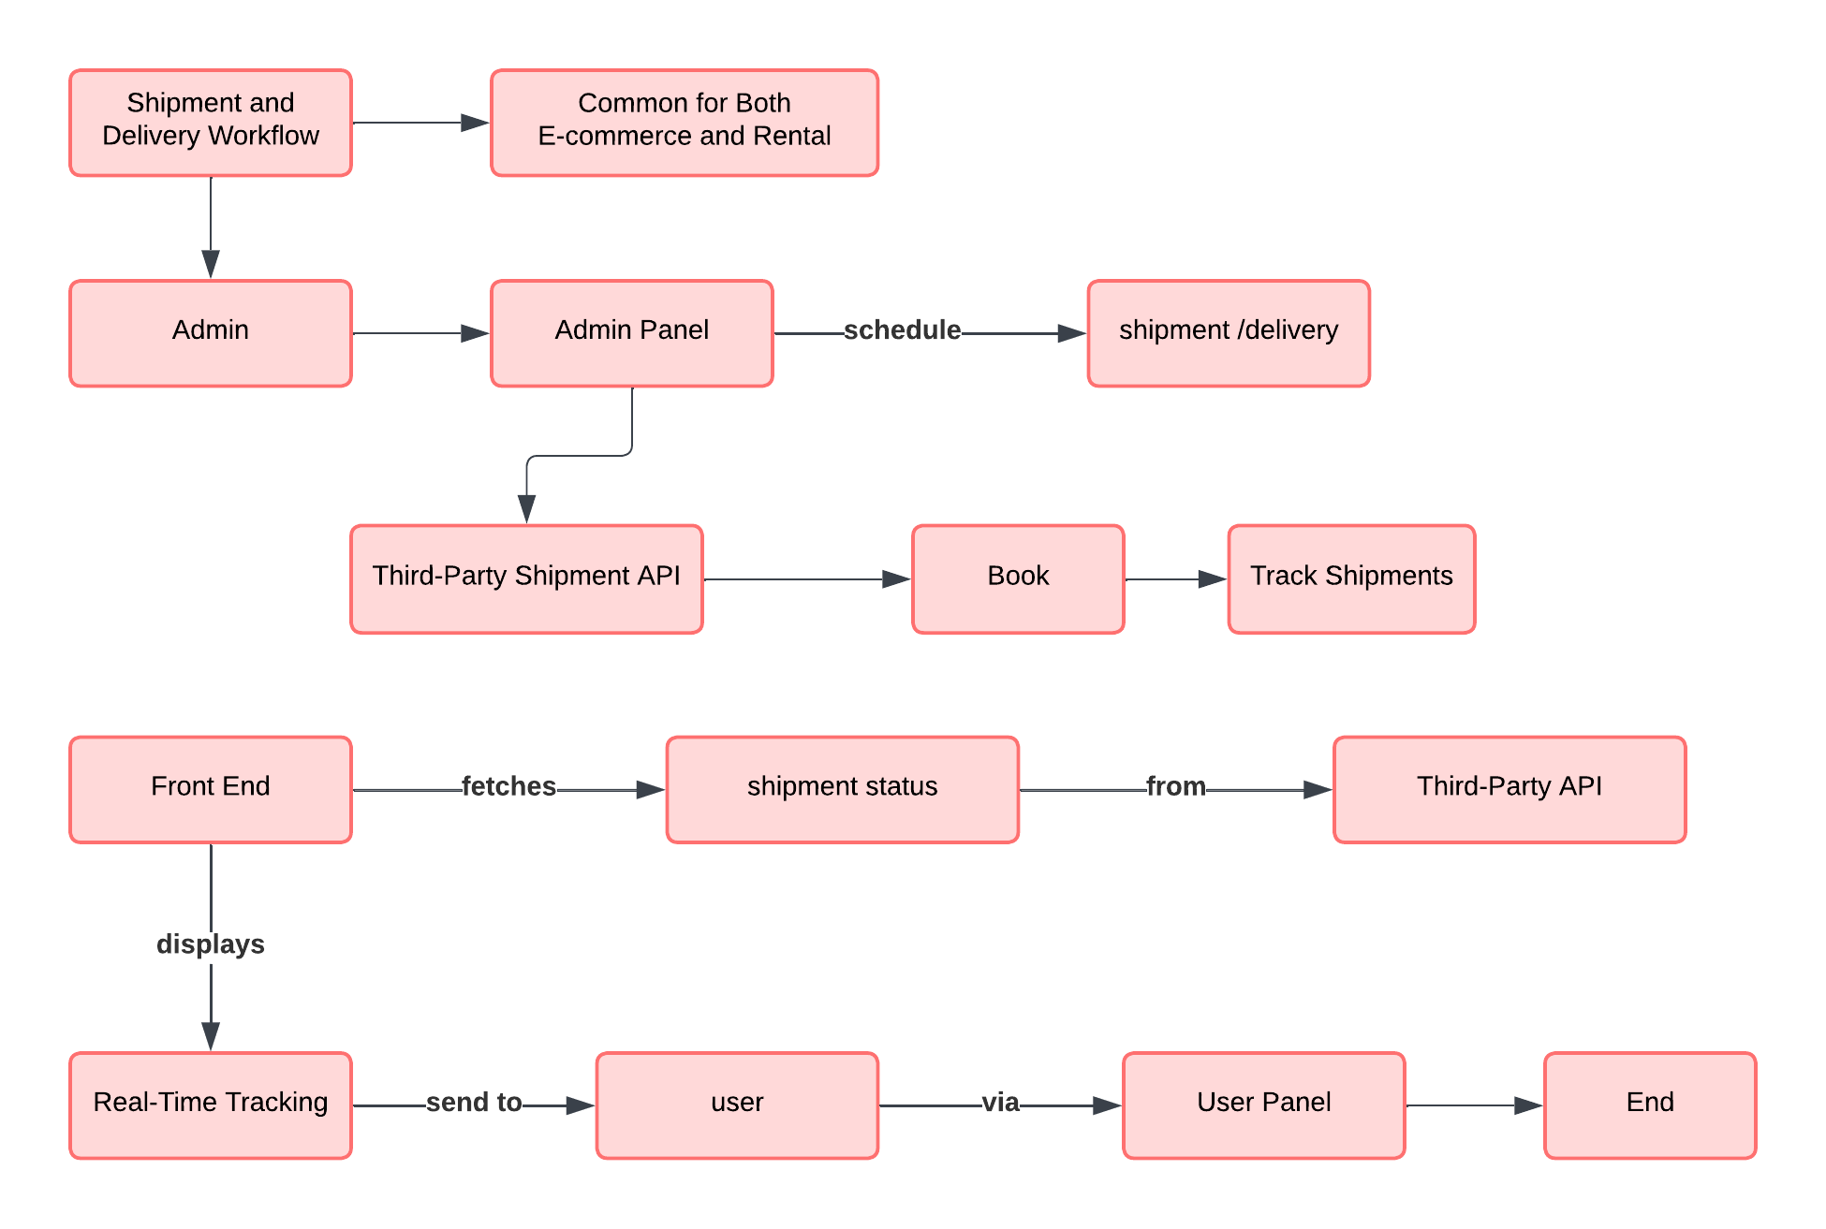**Shipment and Delivery Workflow:**

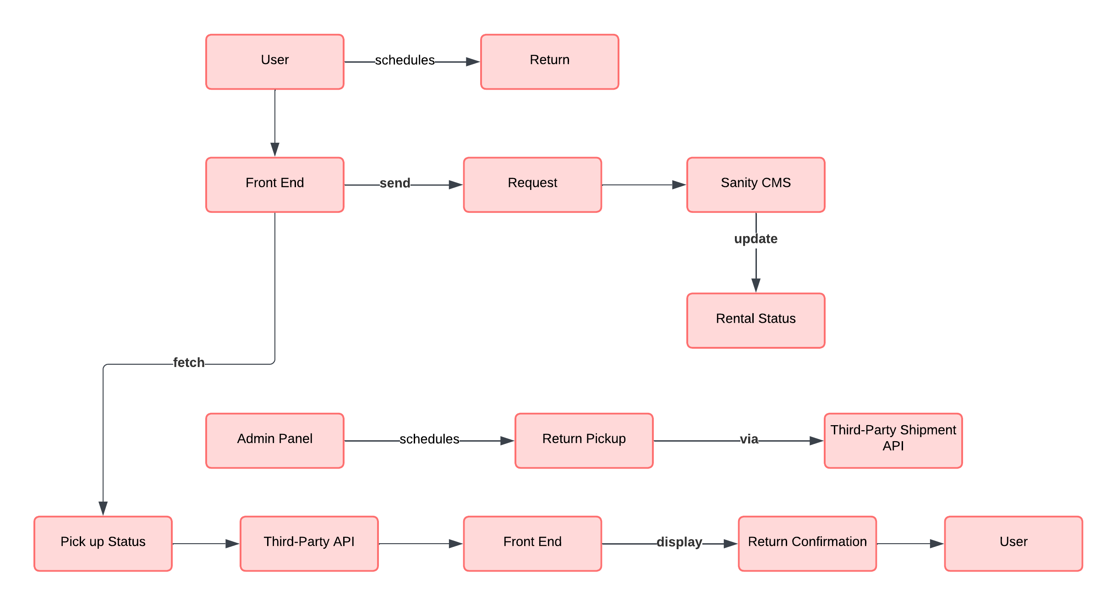**Return Workflow (For Rentals Only):**

**Admin Management Workflow:**

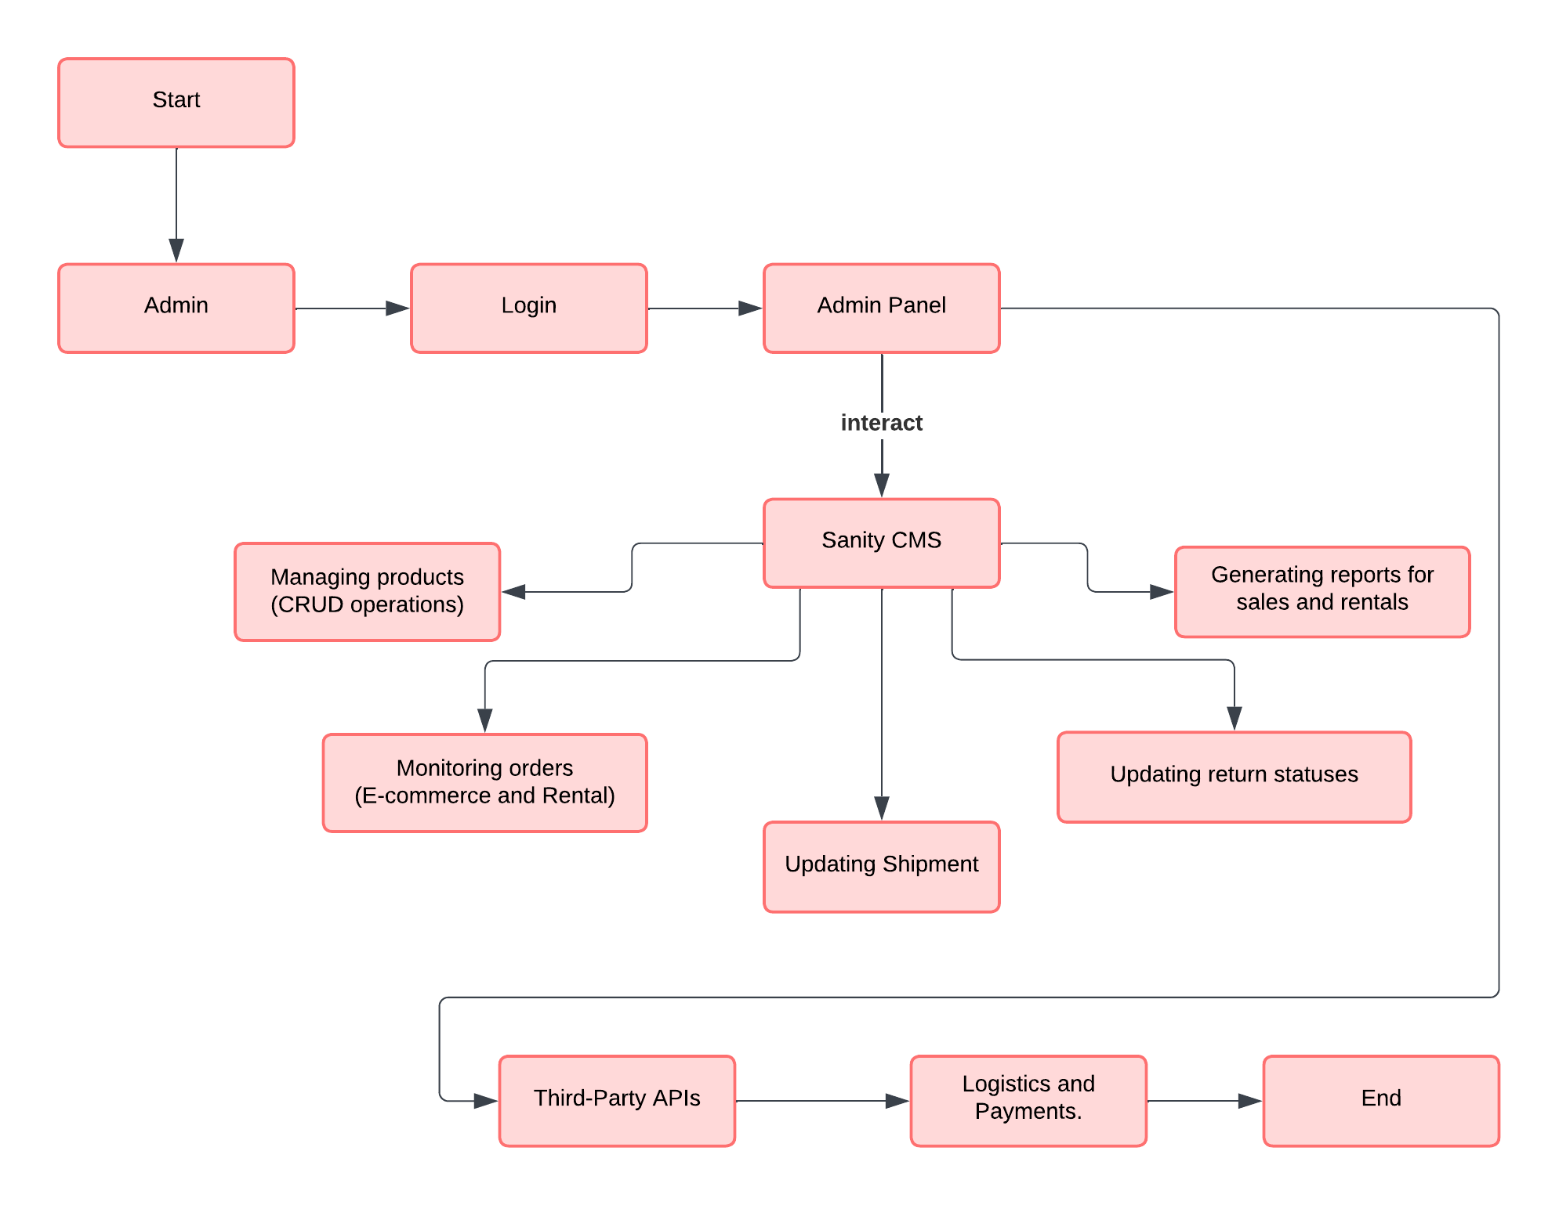

Plan API Requirements